A000-US-Ohio-Pipe-Hopewell-Squirrel Effigy-Ohio Pipestone

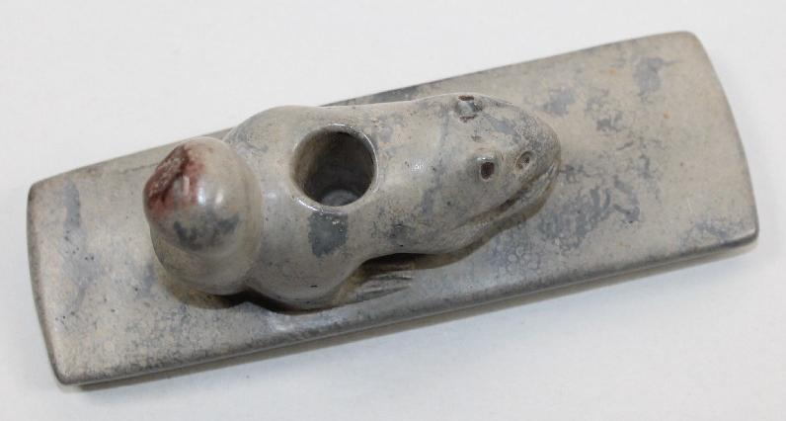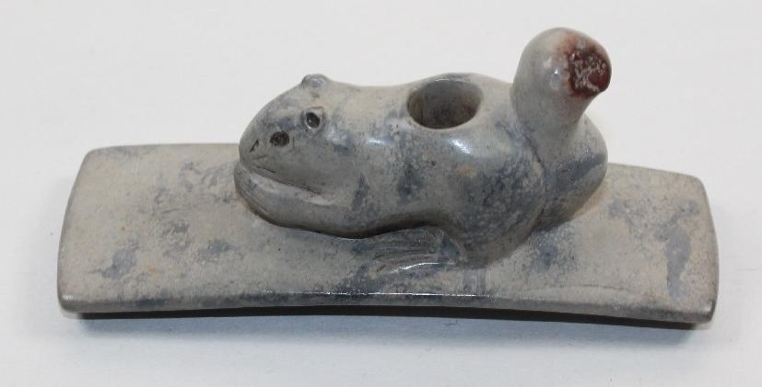

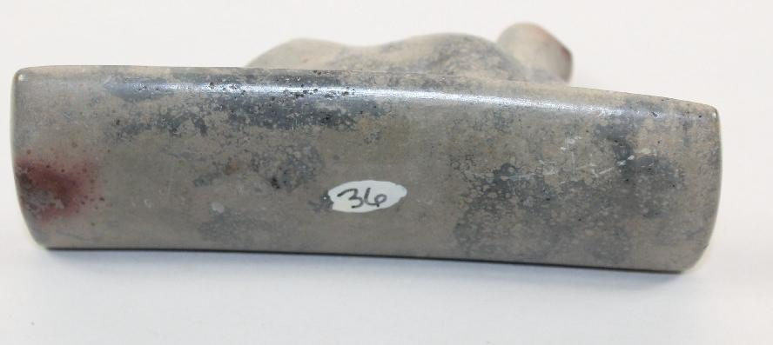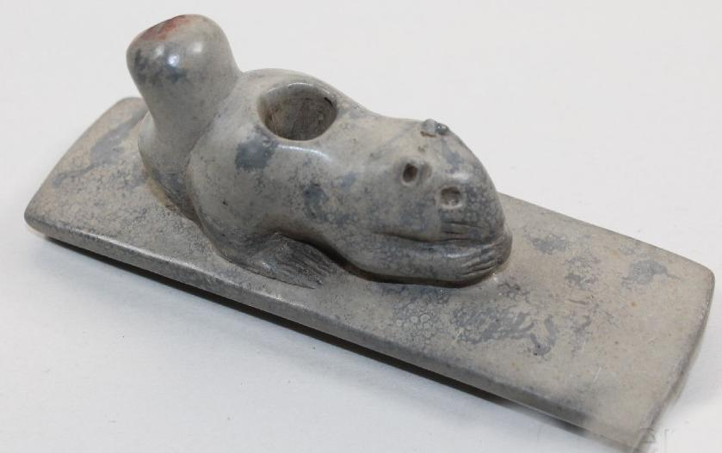

Ohio Hopewell squirrel Effigy Platform Pipe. It is 4" long by 1-1/2" tall by 1-3/8" wide. It is highly detailed. This piece was in the Bob Olson Collection for about 25 years. Bob got this piece from Gary Litherland. The material is exactly what it should be, Ohio pipestone.